# Homework: SASS and CSS Transitions

This document defines homework assignments from the [“Web Fundamentals (HTML & CSS)“ Course @ SoftUni](https://softuni.bg/courses/web-fundamentals/). Please submit as homework a single zip / 7z archive holding the source code of all below described problems.

<http://csstoss.com/>

*/*https://css-tricks.com/snippets/css/a-guide-to-flexbox/*/  
/*https://www.youtube.com/watch?v=G7EIAgfkhmg*/*

## Gradient City

Create a Web page like the picture below (**100% accuracy is required**). You are given the **HTML file.** Use **SASS** to achieve the desired results. Use **mixins** for the gradients. Use variables to implement colors. Implement hover effect for the menu. Making the site responsive is **optional**.

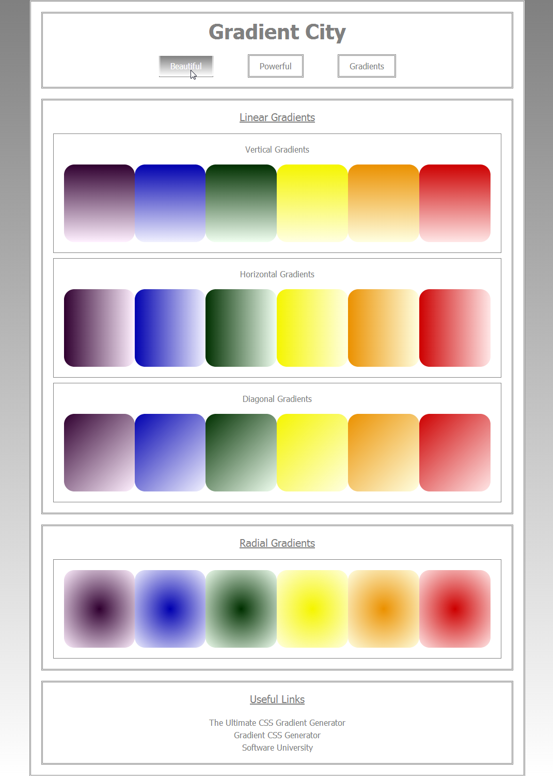

## Crazy Shaky Gallery

Using **CSS animations** create a Web page like the picture below (**100% accuracy is NOT required**).

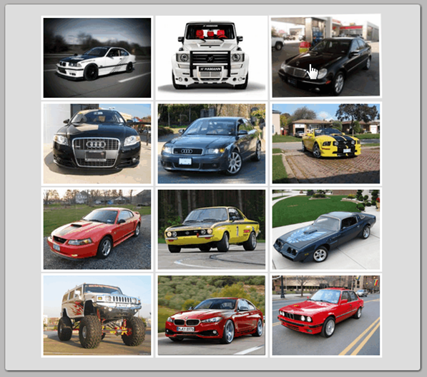 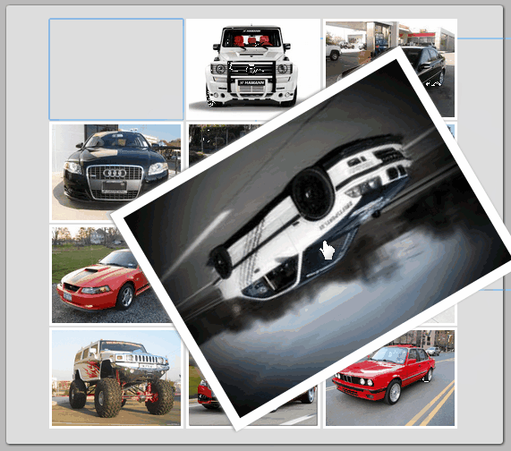

Constrains: Use **CSS3 animation and transitions** to achieve the desired results (on mouse focus and mouse hover). Do not use the same pictures and colors. The animations and transitions must be exactly the same as in the **GIF** file **02-CrazyShakyGallery** (open the GIF file with a browser to view the animations and transitions).

## * Ticking Clock

Create a Web page like the picture below (**100% accuracy is NOT required**).

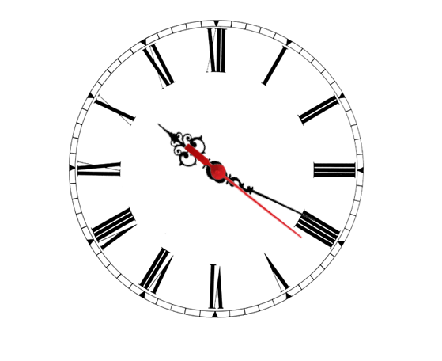

Constrains: Use **CSS3 transitions** and **JavaScript**. Rotate the arrows with CSS rotation. You may use a static image-based clock face.

## ** Jekyll Website

Research and play with [Jekyll static site generator](http://jekyllrb.com). Create a Web site using **Jekyll**, similar to the image below. Install all you need and choose the theme, **different** from the one in the example. Learn how to add post and write **at least two posts**. Add also a few pages.



Hint: Windows users, use this Jekyll installation tutorial: <https://github.com/juthilo/run-jekyll-on-windows/>.